|  |
| --- |
| 张泽光 |
| 电子学习平台 |
| 17301177张泽光  17301166宋佳男 |

|  |
| --- |
| [日期]2020/1/5 |

目录

**项目要求2**

Assignment1**2**

Assignment 23

Assignment 3-53

**项目设计4**

登录注册界面的设计5

个人信息展示界面的设计5

课程表展示界面的设计5

**项目分工6**

**成果展示6**

登录注册界面的展示7

个人信息展示界面的展示9

课程表展示界面的展示11

**一、项目要求**

1, The prototype app should include functions such as,

* Look in the list of courses offered by a e-learing platform
* Navigate to the detailed course introductions such as course info , syllabus, registration and calendar and so on.
* Login to the E-learning platform
* Browse and search the learing materials which can be multi media.

2,The implementation should include but not limited to functions such as,

* Look in the list of courses offered by a e-learing platform
* Navigate to the detailed course introductions such as course info , syllabus, registration and calendar and so on.
* Login to the E-learning platform
* Browse and search the learing materials which can be multi media.

The implementation should include but not limited to following optimization, such as,

3, Look in the list of courses

In general, recyclerview is suggested to be used for course list display. We’d like you to add more information and more enchanting layout for the list item display. E.g, providing different viewitem layouts within one recyclerview; adding videos, statistics diagrams in the item view; anything eye catching. Below is a draft of a sampe item view,

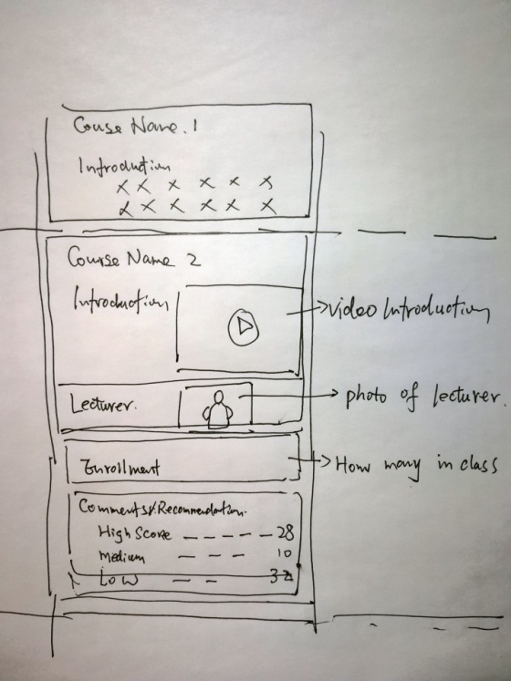

4，Navigating with transition animation.

5，Login to the E-learning platform

User only need to login once, next time open the app, your app will remember the user and recover the UI from user’s last use. To do so, you can use the shared preferences api to store user behavious and run- time status.

6，For long running jobs such as loading/uploading image or video, store in cache file and etc, implmenting with async task or multi thread is necessary.

7 Use broadcast receiver and notification to notify user of server side updates.

**二、设计**

**1、登录注册的设计：**

当我们面临制作登录和注册功能的实现时，我们需要先设计登录界面的布局和注册界面的布局，做到有完整的思路时才开始实现其功能效果会更好。

我们需要做个标题栏，登陆界面，实现登陆界面的功能代码块，注册界面，实现测试界面的功能模块即可完成。

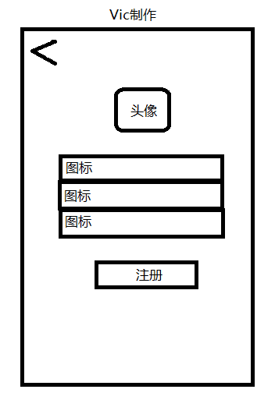

我们舍弃了蛮麻烦的头像，取而代之的是忘记密码和短信验证登录

以及第三方登录。

**2、个人信息展示界面的设计：（想用到RecylerView ）但是调用包失败了**

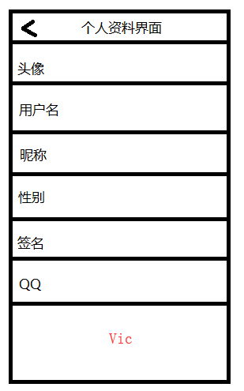

**3、课程表展示的设计：**

创建一个自定义LinearLayout 控件用来装载课程的信息和课程的周数，和节数大概的布局三这样的：

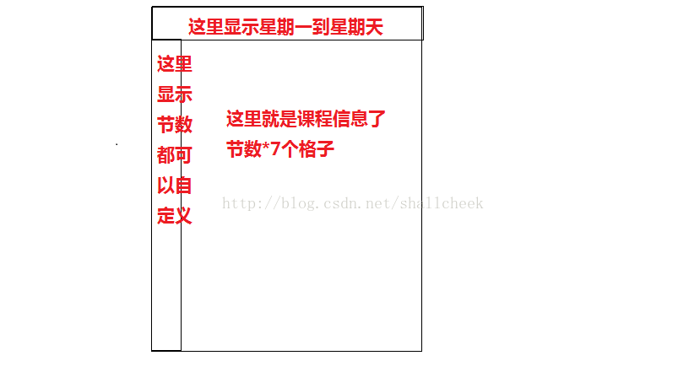

根据上面的看来觉得总体布局我分了两个 上面的星期是一个 下面的节数和格子是一个总体使用Vertical ，单独内部者使用了Horizontal布局中间使用了两种布局线条：

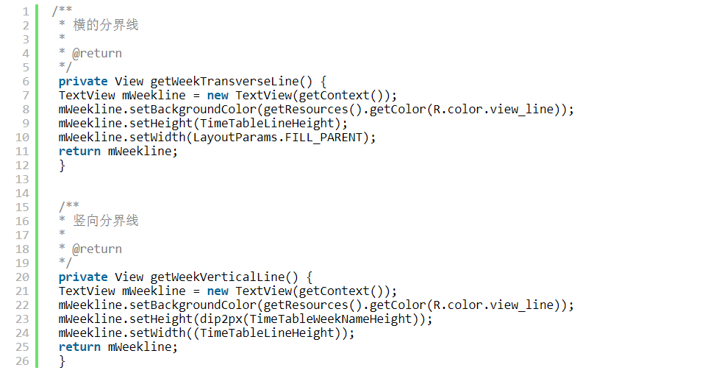

我的课程表的时间遍历：

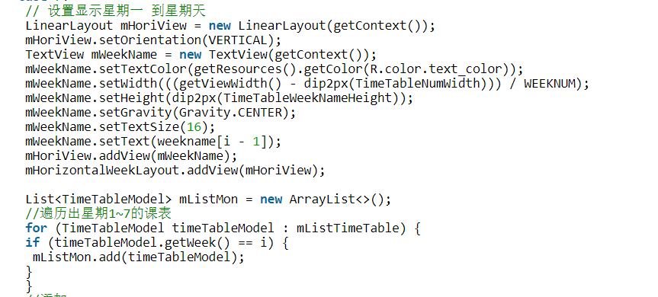

**三、分工**

登录注册：17301177 张泽光

个人信息展示界面：17301166 宋佳男

课程表展示：17301177 张泽光

**四、成果展示：**

**登录：**

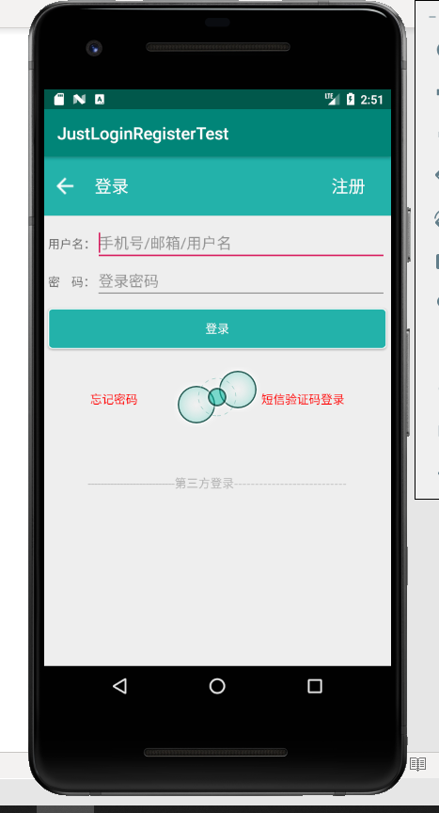

**未经注册的账户不可以登录进去：**

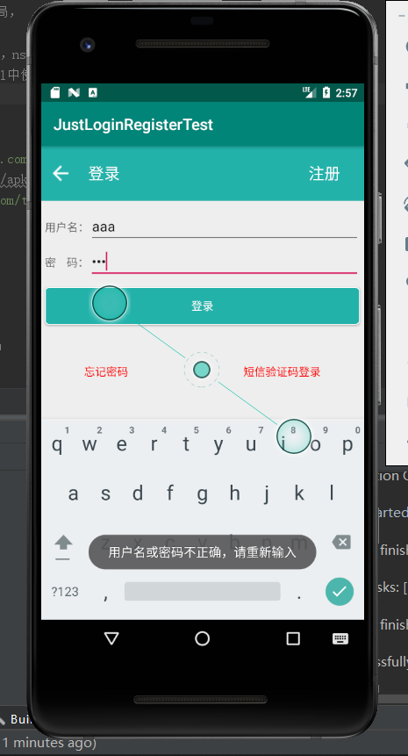

**注册：（验证码部分我放在了注册）（为了美观）**

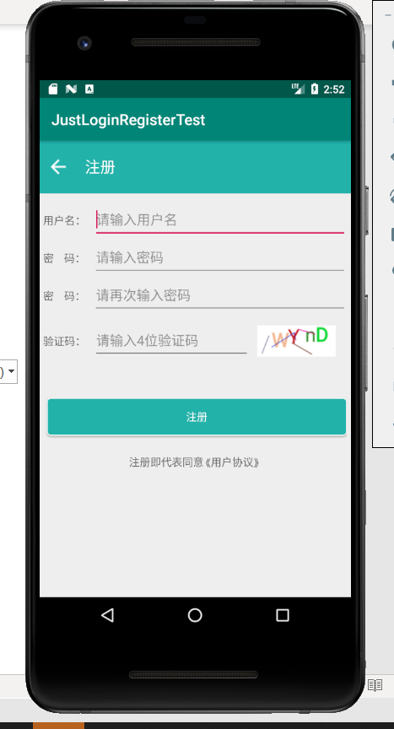

**验证码错误：**

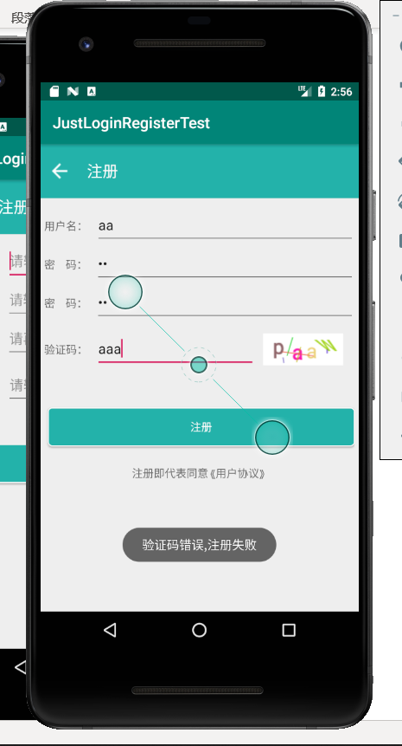

**课程表展示：（左图为登录进去后的初始界面，右图为点击某节课程的详细信息） me是个人信息展示界面是一个从右边出现的侧边栏）（实机测试）**

